.

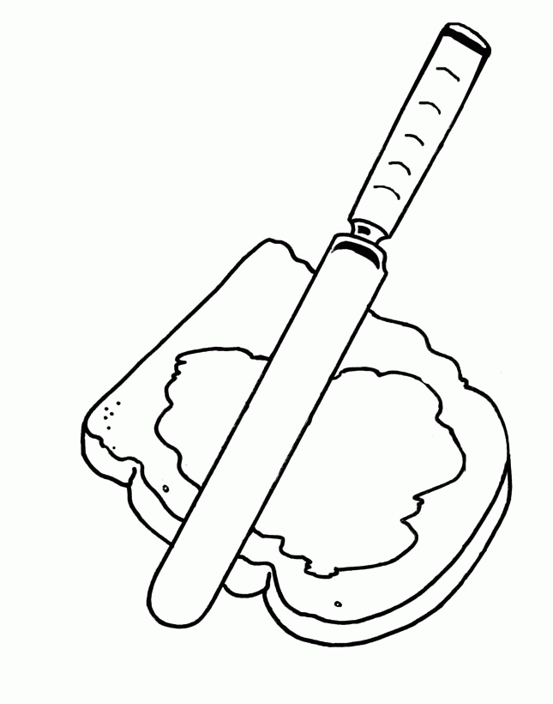

*All Kid’s Meals Served with a Beverage*

PB & J Sandwich *served with fries* 8

kids’



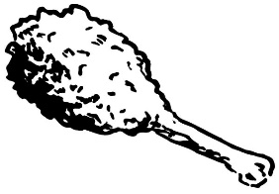 Fried Chicken Tenders *served with fries* 10

Fried Chicken Leg *served with fries* 9

 Kid’s Cheeseburger*American cheese, served with fries* 10

Kid’s Mac & Cheese 9

3 Veggie Plate 11

